Tintern Abbey
By William Wordsworth (1770-1850)
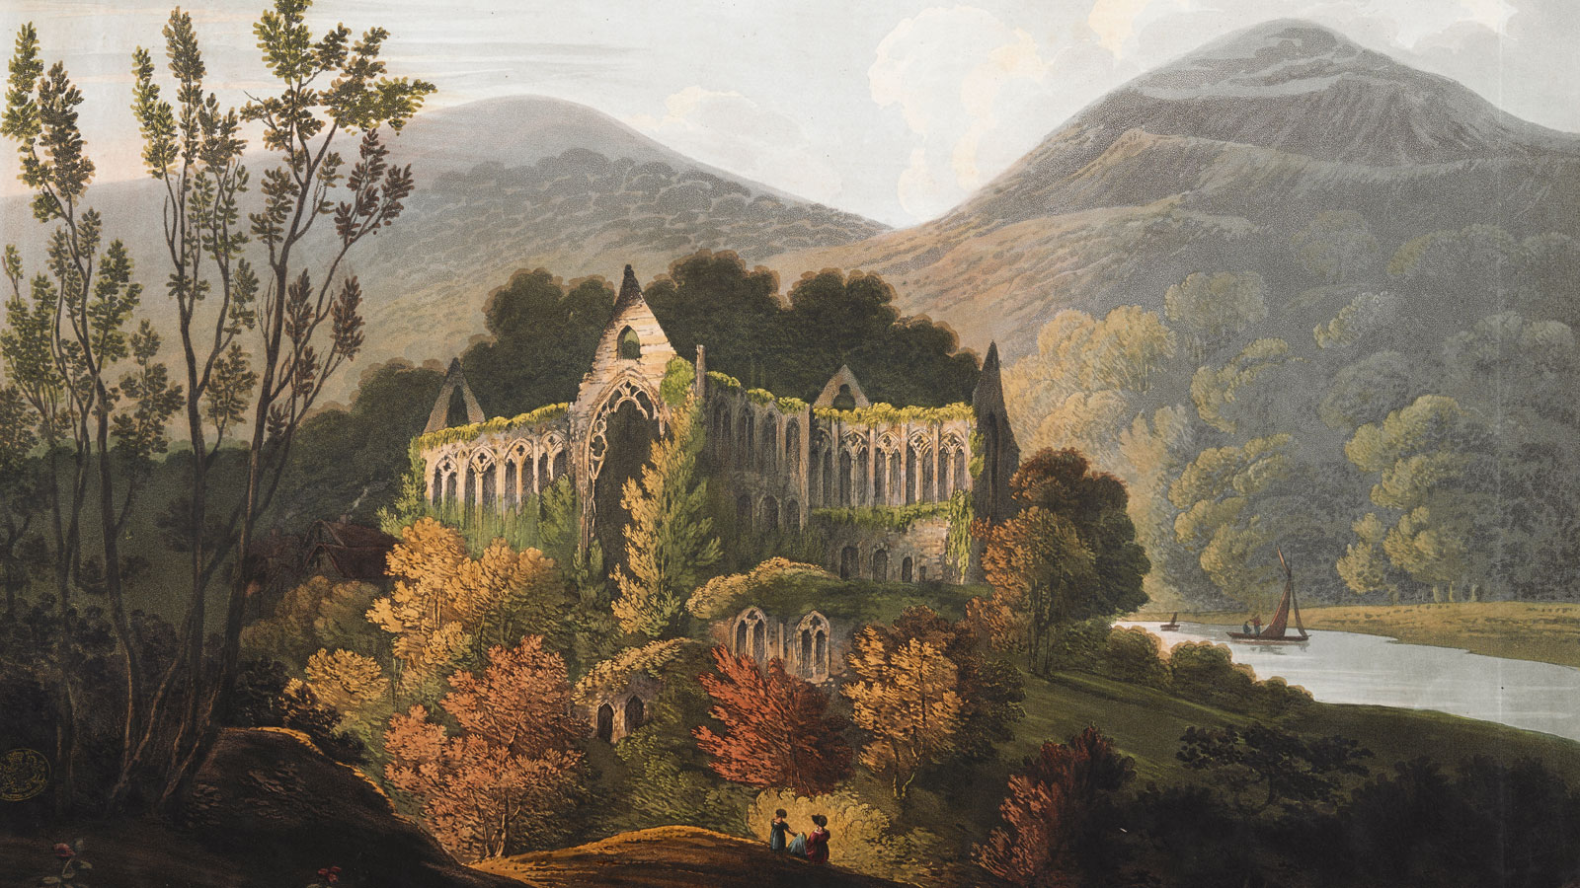
Line
5  10  15  20  25  30  35  40  45  50  55  60  65  70  75  80  85  90  95  100  105  110  115  120  125  130  135  140  145  150  155  160 | Five years have passed; five summers, with the length  Of five long winters! and again I hear  These waters, rolling from their mountain-springs  With a sweet inland murmur. —Once again  Do I behold these steep and lofty cliffs,  Which on a wild secluded scene impress  Thoughts of more deep seclusion; and connect  The landscape with the quiet of the sky.  The day is come when I again repose  Here, under this dark sycamore, and view  These plots of cottage-ground, these orchard-tufts,  Which, at this season, with their unripe fruits,  Among the woods and copses lose themselves,  Nor, with their green and simple hue, disturb  The wild green landscape. Once again I see  These hedge-rows, hardly hedge-rows, little lines  Of sportive wood run wild; these pastoral farms  Green to the very door; and wreathes of smoke  Sent up, in silence, from among the trees,  With some uncertain notice, as might seem,  Of vagrant dwellers in the houseless woods,  Or of some hermit’s cave, where by his fire  The hermit sits alone.  ________________ Though absent long,  These forms of beauty have not been to me,  As is a landscape to a blind man’s eye:  But oft, in lonely rooms, and mid the din  Of towns and cities, I have owed to them,  In hours of weariness, sensations sweet,  Felt in the blood, and felt along the heart,  And passing even into my purer mind  With tranquil restoration:—feelings too  Of unremembered pleasure; such, perhaps,  As may have had no trivial influence  On that best portion of a good man’s life;  His little, nameless, unremembered acts  Of kindness and of love. Nor less, I trust,  To them I may have owed another gift,  Of aspect more sublime; that blessed mood,  In which the burden of the mystery,  In which the heavy and the weary weight  Of all this unintelligible world  Is lighten’d:—that serene and blessed mood,  In which the affections gently lead us on,  Until, the breath of this corporeal frame,  And even the motion of our human blood  Almost suspended, we are laid asleep  In body, and become a living soul:  While with an eye made quiet by the power  Of harmony, and the deep power of joy,  We see into the life of things.  ______________________ If this  Be but a vain belief, yet, oh! how oft,  In darkness, and amid the many shapes  Of joyless day-light; when the fretful stir  Unprofitable, and the fever of the world,  Have hung upon the beatings of my heart,  How oft, in spirit, have I turned to thee  O sylvan Wye! Thou wanderer through the woods,  How often has my spirit turned to thee!  And now, with gleams of half-extinguish’d thought,  With many recognitions dim and faint,  And somewhat of a sad perplexity,  The picture of the mind revives again:  While here I stand, not only with the sense  Of present pleasure, but with pleasing thoughts  That in this moment there is life and food  For future years. And so I dare to hope  Though changed, no doubt, from what I was, when first  I came among these hills; when like a roe  I bounded o’er the mountains, by the sides  Of the deep rivers, and the lonely streams,  Wherever nature led; more like a man  Flying from something that he dreads, than one  Who sought the thing he loved. For nature then  (The coarser pleasures of my boyish days,  And their glad animal movements all gone by,)  To me was all in all.—I cannot paint  What then I was. The sounding cataract  Haunted me like a passion: the tall rock,  The mountain, and the deep and gloomy wood,  Their colors and their forms, were then to me  An appetite: a feeling and a love,  That had no need of a remoter charm,  By thought supplied, or any interest  Unborrowed from the eye.—That time is past,  And all its aching joys are now no more,  And all its dizzy raptures. Not for this  Faint I, nor mourn nor murmur: other gifts  Have followed, for such loss, I would believe,  Abundant recompense. For I have learned  To look on nature, not as in the hour  Of thoughtless youth, but hearing oftentimes  The still, sad music of humanity,  Not harsh nor grating, though of ample power  To chasten and subdue. And I have felt  A presence that disturbs me with the joy  Of elevated thoughts; a sense sublime  Of something far more deeply interfused,  Whose dwelling is the light of setting suns,  And the round ocean, and the living air,  And the blue sky, and in the mind of man,  A motion and a spirit, that impels  All thinking things, all objects of all thought,  And rolls through all things. Therefore am I still  A lover of the meadows and the woods,  And mountains; and of all that we behold  From this green earth; of all the mighty world  Of eye and ear, both what they half-create,  And what perceive; well pleased to recognize  In nature and the language of the sense,  The anchor of my purest thoughts, the nurse,  The guide, the guardian of my heart, and soul  Of all my moral being.  __________________ Nor, perchance,  If I were not thus taught, should I the more  Suffer my genial spirits to decay:  For thou art with me, here, upon the banks  Of this fair river; thou, my dearest Friend,  My dear, dear Friend, and in thy voice I catch  The language of my former heart, and read  My former pleasures in the shooting lights  Of thy wild eyes. Oh! yet a little while  May I behold in thee what I was once,  My dear, dear Sister! And this prayer I make,  Knowing that Nature never did betray  The heart that loved her; ’tis her privilege,  Through all the years of this our life, to lead  From joy to joy: for she can so inform  The mind that is within us, so impress  With quietness and beauty, and so feed  With lofty thoughts, that neither evil tongues,  Rash judgments, nor the sneers of selfish men,  Nor greetings where no kindness is, nor all  The dreary intercourse of daily life,  Shall e’er prevail against us, or disturb  Our cheerful faith that all which we behold  Is full of blessings. Therefore let the moon  Shine on thee in thy solitary walk;  And let the misty mountain winds be free  To blow against thee: and in after years,  When these wild ecstasies shall be matured  Into a sober pleasure, when thy mind  Shall be a mansion for all lovely forms,  Thy memory be as a dwelling-place  For all sweet sounds and harmonies; Oh! then,  If solitude, or fear, or pain, or grief,  Should be thy portion, with what healing thoughts  Of tender joy wilt thou remember me,  And these my exhortations! Nor, perchance,  If I should be, where I no more can hear  Thy voice, nor catch from thy wild eyes these gleams  Of past existence, wilt thou then forget  That on the banks of this delightful stream  We stood together; and that I, so long  A worshipper of Nature, hither came,  Unwearied in that service: rather say  With warmer love, oh! with far deeper zeal  Of holier love. Nor wilt thou then forget,  That after many wanderings, many years  Of absence, these steep woods and lofty cliffs,  And this green pastoral landscape, were to me  More dear, both for themselves, and for thy sake.

Assignment

About the Great Work of Literature
“Lines Written a Few Miles Above Tintern Abbey on Revisiting the Banks of the Wye During a Tour, July 13, 1798” (commonly known as simply “Tintern Abbey”) by British Poet Laureate William Wordsworth (1770-1850) is considered one of the greatest works of British literature. It is within the category of British Romantic poetry (although it is unrhymed, it is in iambic pentameter). The poem is written by Wordsworth upon his visit to the picturesque location of the ruins of Tintern Abbey. He visited here five years before with his sister and this work is a reflection upon that previous visit and other themes.
Instructions
Read “Tintern Abbey.” Feel free to take notes on the text and use a dictionary. Other than a dictionary, no other source of aid may be used. After reading, chose one of the below prompts to write your essay on.
- As discussed earlier this year, British Romantic period poetry is characterized by several dichotomies (interconnected relationship between two things). The first dichotomy is between the positive glorification of nature outside of industrializing city life on the one hand and a negative sense of loneliness on the other hand. The second dichotomy is between a positive sense of creativity, imagination, and emotion on the one hand and a negative sense of irrationality and being overly emotional on the other hand.

Analyze how “Tintern Abbey” fits into one or both of these dichotomies. You may also consider whether Wordsworth is able to overcome the negative sense of both or either dichotomy.

- Memory and inspiration play significant roles “Tintern Abbey.” Choose one of these two themes, memory or inspiration, and talk about the significant role it plays in “Tintern Abbey.” Also, you may connect this theme to another book you have read or your own life experiences or observations (If you do so, be sure to thoroughly cover “Tintern Abbey” before moving on to your own example).
Your response should be at least 500 words in length.

Grading
Your writing will be graded both on its outer form (the mastery of grammar and vocabulary, and length: 75%) and its inner form (the strength, brilliance, and clarity of your analysis: 25%).

